



Implementation of End-to-End List Operations
LAB MANUAL

Disclaimer: The content is curated from online/offline resources and used for educational purpose only
Implementation of End-to-End List Operations

Objective:
- List Creation: Initialize and create a list of fruits to demonstrate basic list functionality.
- Element Access: Access specific elements in the list using both positive and negative indexing to show how to retrieve data.
- Slicing: Demonstrate how to slice the list to obtain a sublist of fruits.
- Element Modification: Show how to modify the list by adding new elements using methods like append and insert, and remove elements using remove.
- Popping Elements: Illustrate the use of the pop method to remove and return the last item from the list.
- Length Calculation: Use the len function to determine the number of items in the list.
- Membership Testing: Demonstrate how to check if a specific item exists in the list using the in keyword.
- Iteration: Use a for loop to iterate over the list and print each fruit.
- Sorting and Reversing: Showcase how to sort the list alphabetically and reverse the order of elements.
- List Comprehension: Provide an example of list comprehension to create a new list based on certain conditions.
- Copying Lists: Show how to create a copy of the list using the copy method to preserve the original data.
- Clearing the List: Demonstrate how to remove all items from the list using the clear method.
- Extending Lists: Use the extend method to add elements from another list to the current list.
- Counting Elements: Count how many times a specific item appears in the list using the count method.
- Finding Index: Determine the index of a specific element using the index method.
- Removing by Index: Show how to remove an element by its index using the del statement.
- Nested Lists: Illustrate how to create and manage nested lists (lists containing other lists) for more complex data structures.
Problem Statement:
- The goal of this program is to manage and manipulate a list of fruits by performing various operations. Users can create a list of fruits, modify it by adding or removing items, access specific elements, sort and reverse the list, and perform other operations like counting and copying. The program will help users understand how to work with lists in Python effectively.

Equipment Required:
- Install VS Code - https://code.visualstudio.com/download
- Download Python Installer File - https://www.python.org/downloads/
Prerequisites:
- Basic Computer Skills - Anyone starting to learn computer programming needs basic computer skills.
- Basics of control statements

Procedure:#
Task 1: Implementation of Creating a list

Task 1: Implementation of Creating a list
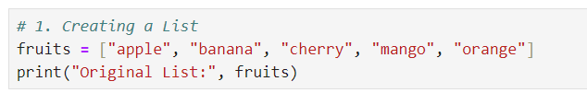
Output:
Task 2: Implementation of Accessing Elements in a List
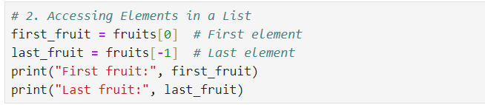

Output
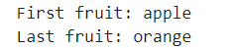
Task 3: Implementation of Slicing a List
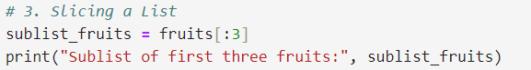
Output:
Task 4: Implementation of Adding elements to a List
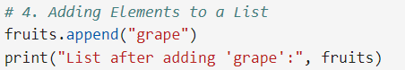
Output:
iint
Task 5: Implementation of Inserting elements into a list

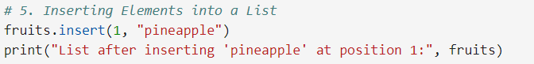
Output:
Task 6: Implementation of Removing elements from a List
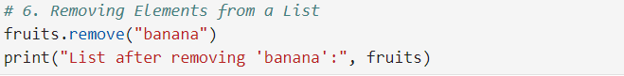

Output:
Task 7: Implementation of Popping Elements from a List

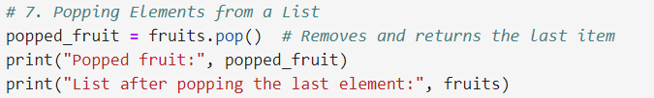
Output:
Task 8: Implementation of finding the lenght of list
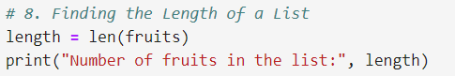
Output:
Task 9: Implementation of checking membership in a list
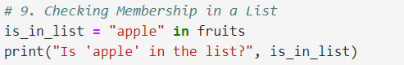
Output:
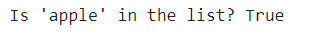
Task 10: Implementation of Iterating over a list

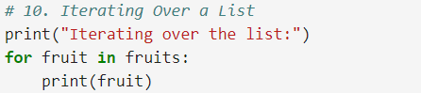
Output:
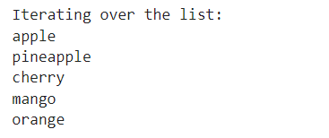

Task 11: Implementation of sorting a list

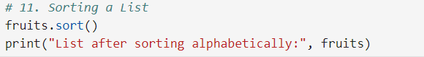#
Output:
Task 12: Implementation of reversing a list
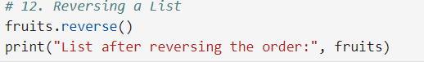
Output:
Task 13: Implementation of list comperhensions
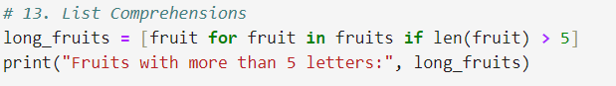
Output:
Task 14: Implementation of copyiing a list
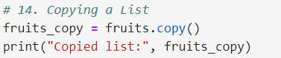
Output:
Task 15: Implementation of clearing a list
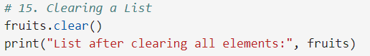
Output:
Task 16: Implementation of extending a list with another list
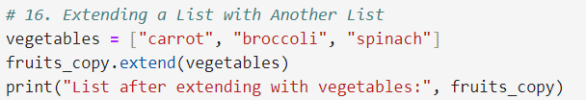
Output:
Task 17: Implementation of counting occurrences of an element in a list

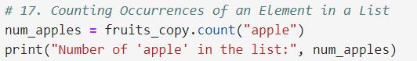
Output:

Task 18: Implementation of finding the index of an element
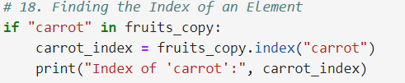
Output:
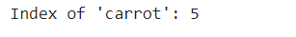
Task 19: Implementation of removing an element by index

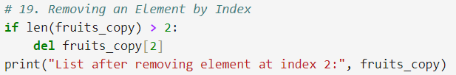
Output:
Task 20: Implementation of nested list
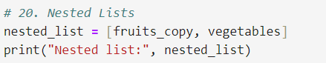
Output:

